

**STANDARD PROCEDURE**



*Some of these standards are based on sections of the “Mold Inspection” Standards - IAC2. However, these standards were created by Vantage Point Inspections and are customized to provide a more simple and affordable way of just testing for mold in the air.*

**STANDARD MOLD TESTING PROCEDURE**

**1.0 AIR SAMPLES**

**1.1 Locations**

**1.1.1 Control Sample**

The inspector will take an exterior control air sample within 10ft of the home. The equipment will be placed in an area that the inspector believes will be protected from wind.

This recommendation is given to us by the laboratory we use, [Sporecyte](https://sporecyte.com/about-us/).

If more control air samples are needed, there will be a $50 charge for each air sample.

*The laboratory compares the outdoor control air sample to the air samples within the home to see if there are mold spores found in the home that aren’t found outside.*

**1.1.2 Indoor Samples**

The inspector will take air samples in the locations specified by the client.

**Unless the location is specified by the client, follow these standards:**

**1.1.3 Indoor Sample Standards (Modified IAC2 Standards)**

* The inspector shall perform at least two (2) indoor samples. Additional samples may be performed at the discretion of the inspector and/or client.

**1.1.3.1 Areas of Concern**

* At least one (1) air sample shall be taken near the center of EACH room or area of the building in which there are areas of concern (moisture intrusion, water damage, musty odors, visible apparent mold growth, and conditions conducive to mold growth).

**1.1.3.2 No Areas of Concern**

* At least one (1) indoor air sample shall be taken in the most lived-in common room, such as the family, living, or entertainment room (The location shall be determined at the discretion of the inspector).

**1.1.3.3 Location**

* An indoor air sampling should only take place in a livable space in the building. Sampling in areas such as closets, under-floor crawlspaces, unfinished attics, storage or utility rooms, or inside the HVAC system is prohibited.
* The indoor air sample should be taken in the middle or center area of the area or room.
* The air collection device should be at head height (about three to six feet above the floor surface).

**1.1.3.4 Ten Minutes**

* Inside the building, the air pump sampling should run for 10 minutes. If there is a lot of indoor activity, then the air pump sampling should be reduced to 5 minutes. If there is an active source of dust, such as construction or cleaning, then the air sampling time should be reduced to 1 minute. Be sure to follow the recommendations of the manufacturer of the sampling device or collector; there are some devices that are designed to take a sample in 5 mintues (i.e. Z5 cassette).

**1.1.3.5 Sampling**

* The sampling equipment must be protected, clean, and properly maintained at all times. The sampling device shall be clean, free from dirt or debris prior to starting a sample. If re-usable collection devices are used, then they shall be handled and cleaned prior to use in accordance with the manufacturer’s recommendation. The collector may re-usable and have sticky slides already prepared, or the collector may be a one-time-use self-contained device.
* Slides, cassettes, and one-time-use devices should be stored in cool, dry environments. The slides must be protected from direct sunlight. Sampling devices (slides, swabs, cassettes, tapes) older than one year should not be used.
* Set the air collector at a normal breathing height, which is about 3 to 6 feet above the ground level or floor surface. A tripod is typically used to set the collector height.
* Calibrate the flow of the pump. Do not attach the sampling device, cassette or collector on the tubing yet. Measure the flow rate of the pump with a rotameter that has been calibrated to a standard. Make sure that the flow rate is set to the manufacturer’s recommendation. For example, an Air-O-Cell cassette flow rate is 15 liters of air per minute. The pump should be calibrated regularly (once a day). A record of calibrations should be kept in a work ledger or logbook.
* After calibration, securely attach the tubing of the pump to the sampling device or collector. Turn on the pump. Start sampling. Record start time.
* After turning on the air pump, check the airflow rate. The flow rate should not vary. A flow change greater than five percent (5%) requires a new air sample to be taken. All air samples must have the same volume. A digital time controller on the equipment is highly recommended.
* Examine the collector. There should not be an overload on the slide. There should be a fine trace, hardly visible to the human eye, of dust and spores on the slide. A slide that has an easily visible trace on it may be unreadable. If that is the case, the environmental conditions may need improvement or a new sampling location may be needed. If a slide is heavy, a new sample should be taken.
* Remember, all air samples must have the same volume. Refer to manufacturer’s recommendations about sampling time and volume for each type of sampling device.
* Record the time that the pump stopped. Mark the sampling device with a unique sampling number. Record that information on the Chain-of-Custody.
* Place slides in a protective carrying case. Or close the collector if a cassette is used. A new sample must be taken, if a slide is accidentally touched, smeared, or contaminated, because it will be unreadable.

**2.0 AMOUNT OF SAMPLES**

**2.1 AIR SAMPLES**

The inspector will take two air samples within the home. The client can request Additional air samples within the online agreement before the inspection starts. If the agreement has already been signed, the inspector can add more samples to the agreement and then send out a new agreement for the client to sign.

Getting at least 1 air sample for every 1,000 sq ft of living space is a general recommendation, but is not required.

After the 2 standard samples, each additional sample will have a $50 fee.

**2.2 SURFACE SAMPLES**

Surface samples are not included with the standard mold testing fee. If the client would like surface samples to be taken, they can be requested within the online agreement or via email/text prior to the inspection start time.

Surface samples are $50 for each sample.

There is a section within the agreement where the client can agree to have the inspector take a surface sample of mold-like growth for each location it is found. *For example, if mold-like growth on the basement bathroom wall and mold-like growth on the roof structure, 2 surface samples will be taken. One sample is for the visible growth in the basement bathroom, and one sample is for the roof structure.*

**2.2.1 Mold Surface Sample Decision Chart**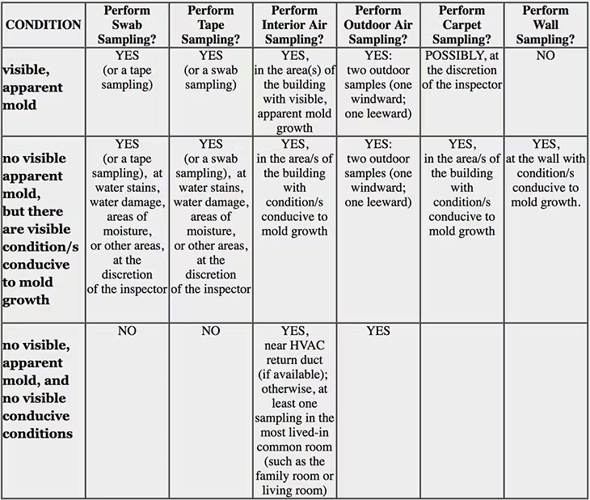

**3.0 FEES**

**3.1 Standard “Mold Testing: Fee: $325**

* + Includes 2 indoor samples and 1 outdoor control sample

**3.2 Only Surface Sample Fee: $175**

* **Includes 1 surface sample. Additional samples are $50 each.**

**3.3 Additional Fees:**

**$50 per additional air sample or surface sample**

* + **Paying for additional samples after the inspection start time**
    - If the client agrees to have surface samples taken where mold-like growth is visible, an updated agreement will be sent out for the client to read and sign. The invoice will also be updated. If the fee has already been paid, the client only needs to pay the difference for the added sample(s) fee.
    - The report/results will be locked until the added fees have been paid and the updated agreement has been signed.

**4.0 WEATHER CONDITIONS**

**4.1 Cancelation**

The inspector will reschedule the service if there is extreme weather. Extreme weather can affect the control sample as well as the samples taken within the home. Examples of extreme weather are strong winds, heavy snowfall, and heavy rain.

**4.2 Testing During Extreme Weather**

If the client has a small time frame and can’t wait to reschedule the mold testing, they can sign an agreement agreeing that proceeding with the mold test may result in inaccurate results.

**5.0 WHEN ADDED TO A HOME INSPECTION**

**5.1 General Information**

* A home inspection is a very thorough inspection of the interior and exterior of the home. The inspection can reveal signs of past or present water leakage. Water leakage is the main cause of mold growth. During the inspection the inspector may locate visible mold growth or strong musty odors that indicate there may be mold present.

**5.2 Add-On**

* The standards that are followed during a home inspection are more in depth than those that are followed in the IAC2 standards (these standards are followed when we perform a full “Mold Inspection”). Since these standards are exceeded during the home inspection we do not offer a “Mold Inspection” as an add-on for a home inspection. Any visible issue that can lead to mold growth will be pointed out in the home inspection report.
* The explained procedures for air and surface sampling will be followed when “Mold Testing” is offered as a separate service or an add-on for a home inspection.

**6.0 Limitations & Exclusions**

**6.1 Limitations:**

**I. The mold testing is not a visual inspection (please refer to our other “mold inspection” service for a more thorough service).  
II. The mold test is not a warranty, guarantee, or insurance policy.  
III. The mold inspection is not technically exhaustive.  
IV. The mold inspection will not identify concealed or latent conditions or defects.  
V. The mold inspection will not identify mold growth not readily visible at the time of the inspection.  
VI. The scope of a mold inspection does not include future conditions or events  
VII. The scope of a mold inspection does not include hidden mold growth or future mold growth.**

**VII. Surface sampling is only done when the client requests or if the inspector sees any visible mold while testing the air. Since this is only a mold test service, the inspector won’t inspect the inside or outside of the building for visible mold growth or noticeable musty odors.**

**6.1 Exclusions:**

**The inspector is not required to:**

**A. Determine the presence of hidden mold by physical examination or sampling.  
B. Report replacement or repair cost estimates.  
C. Lift carpeting or padding.  
D. Inspect any other environmental issue.  
E. Determine the cause or reason of any condition.  
F. Perform a geotechnical, structural, geological evaluation.  
G. Move any personal items or other inspection obstructions, such as, but not limited to: insulation, throw rugs, furniture, floor or wall coverings, ceiling tiles, window coverings, equipment, plants, ice, debris, snow, water, dirt, foliage, or appliances.  
H. Dismantle, open, or uncover any system or component.  
I. Enter or access any area, crawlspace, or attic space, which, in the opinion of the inspector, may be unsafe or may risk personal safety.  
J. Do anything that may be unsafe or dangerous to the inspector or others or damage property according to the opinion of the inspector.  
K. Determine the insurability of a property.**